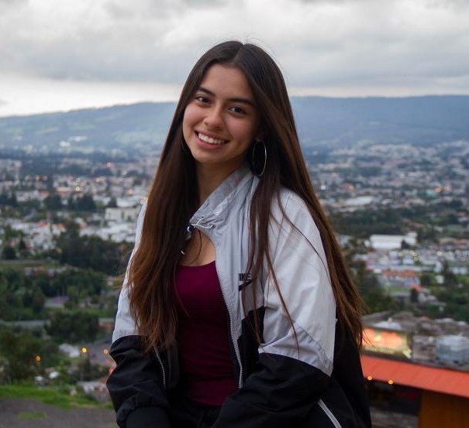
Meet IPSL’s Newest Student Ambassador!

Gabriela Perez Mendez

My story: Colombia, Ecuador, and peru…

Growing up in the United States as the daughter of a Puerto Rican mother, I always understood the importance of values and customs. I like to call my home ``Baby Puerto Rico”, because I may not have been raised there, but my mom brought her culture and traditions with her when she moved to Indiana. When I started Kindergarten I did not know any English and I struggled communicating even with the Spanish speaking faculty, since we had different dialects. Being raised in what feels like this in between is what I believe sparked that interest in other cultures, especially South America and led me to participate in an IPSL Study Abroad program for a semester in Colombia, Ecuador and Peru through Butler.

Word of advice:
Not making a decision is still a choice, you decided to not do anything. The only person stopping us from really going out there and experiencing the world is ourselves. Being able to step out of our comfort zone and go that extra mile if needed to achieve our goals, is always worth it. We must never forget that the storms never stop, but neither do the rainbows. Keep going, take risks, ask questions, and knock on the doors till they open.

Colombia: The place I was most excited to visit since my step-father is from Colombia and he and his family have been a part of my life since I was 3 years old. Being able to experience this with my family who also went to visit me while I was in Cartagena, was truly a blessing. I didn’t just meet people and become friends, I met family. It felt as if I was reconnecting with a family I already knew my whole life.

Ecuador: To this day I still speak with my host dad and siblings. The bonds that are formed with host families are beyond what words could explain. Be open, be curious and communicate (even if you know little of the host language)! Although I highly recommend learning the language at least basics, it will really help you connect with others, especially those from the community. Human communication is the key to understanding and understanding helps us make a better world.

Peru: If I could choose any place to live, it would be Peru. I basically spent the whole month in Cusco with my host family, other than the week at Valle Sagrado when visiting Machu Picchu. I had keys to my home, took the bus, and really got to immerse myself in their culture and traditions.

I would love to talk about YOU going abroad. Feel free to contact me at (317)-692-9092.

